_____________________________________________________________



04 DEPT - Vehicle Dynamics
SRP-038 – Brakes
Development Process

Sunswift Vision Statement:
Sunswift Racing 8 is a high-performance prototype vehicle that aims to showcase as many cutting-edge technologies as possible. It is versatile in providing a refined driving experience both on the road and around a racetrack. Overall, the car has a high excitement factor that entices people to drive it, defeating the misconception that solar electric vehicles cannot be interesting and engaging.

- Table of Contents
1 - Conceptual Design 4
1.1 - Projects 5
Project Scope 5
Terms, Definitions, and Abbreviations 5
Responsible and supporting departments 5
Project interfaces 5
Assigned team members 6
1.2 - Design Factors 6
Lifecycle factors 7
Risk Analysis 7
Innovation Analysis 7
Manufacture and Procurement 8
Design and Production plan 8
Cost Analysis: 8
Educational Outcome: 8
Upskilling Development: 9
1.3 - Conceptual Requirements 9
Functional requirements 10
Performance requirements 10
Interface requirements 12
External requirements 12
2 - Preliminary Design 13
2.1 - Key Components 14
Key Components definition 14
2.2 - Design Factors 14
Lifecycle 14
Risk 14
Innovation 15
Manufacture and Procurement 15
Design and Production Plan 16
Cost Analysis 16
17
Educational Outcome 17
Upskilling Development 17
2.3 - Preliminary Requirements 17
Functional Requirements 18
18
Performance Requirements 18
Reliability Requirements 18
Interface Requirements 18
External Requirements 18
CAMBER: 20
TOE: 20
References 21

- Document Revisions
Document Version | Date | Description | Approved by
0.1 | 30/10/2022 | Conceptual Design | Declan Watson
0.2 |  | Preliminary Design
- List of Tables and Figures
List of Figures
Figure number | Title | Page number

List of Tables
Table 1: Terms, Definitions, and Abbreviations 4
Table 2: Risk Analysis Table 5
Table 3: Manufacture and Procurement 6
Table 4: Functional requirements table (Normal conditions) 8
Table 5: Performance requirements (Teamwide specifications) 9
Table 6: Interface requirements (Project/System interfaces) 9
Table 7: External requirements 9

1 - Conceptual Design

1.1 - Projects

Project Scope
SRP – 038 is responsible for the development of the Brakes subsystem acting within Vehicle Dynamics. This will consist of from (not including) the pedal through the hydraulic lines, master cylinder and brake booster, through to the callipers and brake discs. Also, Brakes will be responsible for the design of the park brake. The aim of the brakes department is to research viable braking systems and options in order to determine packaging requirements, fundamental for other vehicle systems and importantly the design of suspension uprights.

Terms, Definitions, and Abbreviations
Table 1: Terms, Definitions, and Abbreviations
Abbreviation/Terms | Definition
TPM | Technical performance measures
SR8 | Sunswift 8
OTS | Off-the-Shelf

Responsible and supporting departments
Vehicle Dynamics (Responsible)
Interior (Supporting)

Project interfaces
SRP – 038 will interface with the following departments:
Table 1: Terms, Definitions, and Abbreviations
Relevant Departments | Description
SRP – 010 Test Mule | Test mule has accurate dimensions (pickup points and barking system dimensions) for effective testing and optimization.
SRP – 022 Human Machine Interface | Braking controls that can be adjusted via interfaces on the steering wheel such as brake bias.
SRP – 026 Pedals | Providing interior with specific details such as type of pedal as well as percentages of pedal travel
SRP – 035 Performance optimisation | Braking performance can be adjusted to suit conditions, optimize braking distance, and minimize braking temperatures.
SRP – 040 Steering | Ensuring that braking components (eg lines) do not interfere with steering components.
SRP – 041 Suspension | Pick up points and locations that will be necessary for the construction of uprights.
SRP – 042 Wheels | Ensure that brake disks and calipers fit within the inside barrel of the wheel.
SRP8 - 015 Cruise Control | If it is adaptive, brakes must be used when distance shortens between the car and the object in front of it
SRP8 - 098 Automated Parking | Brakes must be used
SRP8-059 Sensors | Sensors will be used to monitor pressure and collect data
SRP8-014 Regen Braking | Regen braking system must be implemented into the system

Assigned team members
- Martin Nguyen (Project Lead, 24T1 – Present)
- Declan Watson

1.2 - Design Factors

Lifecycle factors
The brake system in theory should have a lifespan which mimics that of the vehicle. Disposable components of the braking system include hydraulic lines, piston seals, brake pads and brake discs. ​
It should be considered throughout preliminary design as the braking system should last over the average lifespan of the typical passenger vehicle. ​
Typically for passenger vehicles this lifespan is 90,000 km’s for brake pads and 150,000 km’s for brake discs.

Risk Analysis
Major concerns would surround the braking force and impact of heat. Brakes when heated (more specifically overheated) lack braking performance. ​
Typical braking performance should be compared among varied materials to optimize braking performance and vehicle safety. ​
Table 2: Risk Analysis Table
Risk | Response Category | Mitigation Strategy
Braking Hardware
Brake Fade | Mitigate, Avoid | Focus on a solution which dissipates heat.  Reduce the number of heavy braking intervals while on track.
Brake Pad (and Disc) wear | Accept | Regular servicing/inspections which is included as a vehicle inspection check.  See lifecycle for lifespan of these components.
Brake squeaks | Mitigate | Every time the brakes have come into contact with someone, they are to be cleaned with Brake Cleaner.
Braking System
Brake leak | Mitigation | Use of braided lines as well as regular inspections of the braking hardware to mitigate splits in brake lines.  The use of Teflon tape at all fittings.
Brake Booster fails | Servicing, Mitigation | If the Brake Booster is to fail the system will be bypassed and intermechanical pressure will remain between driver and braking hardware
Regen

Innovation Analysis

Material analysis, lifecycle analysis and comparisons will need to be conducted to determine feasible options but also options which are worthwhile. ​

This would include the possibility of manufacturing in house of components to justify some decisions. ​

It is important to keep in mind that by trying to find innovative solutions it would be best for us to manufacture them rather than buying them off-the-shelf. By doing this factor of safety will be impacted which must be tested to ensure the upkeep of both legal standards but also road-user safety.

Manufacture and Procurement
This would include the exploration of production of braking components such as brake discs. This would be with the help of McConaughy. Otherwise, off-the-shelf options must be explored. ​
With the braking system being such a fundamental factor of safety of a passenger vehicle it would require a high level of attention and strict procedures if it were to be manufactured.
Table 3: Manufacture and Procurement
Item | Method
Mounting Bell | In house CAM or send to Sorensen or can be purchased OTS.
Discs | Purchased OTS

Design and Production plan
Key milestones include:
- Preliminary Design
- Detailed Design
- Construction

Cost Analysis:
The main components that make up the bulk of the cost for the brake system include the callipers, brake discs, master cylinders, IBSe9’s and electronically activated callipers due to their complex design. The cost of the parts can be reduced using partnerships with AP Racing, Comp Friction and LSP. The table below provides an estimation of the costs of each brake system component based on information provided by distributers online.
Component | Component Code | Quantity | Link | Cost per unit in AUD (Based on approximate prices available) | Total
Brake callipers | AP Racing CP9200-2S0BG | 2 | https://www.demon-tweeks.com/au/ap-racing-cp9200-4-piston-two-piece-forged-radial-mount-brake-caliper-7000565/ | $963.07 | $1926.14
Brake callipers | AP Racing CP9200-3S0BG | 2 | https://www.demon-tweeks.com/au/ap-racing-cp9200-4-piston-two-piece-forged-radial-mount-brake-caliper-7000565/ | $963.07 | $1926.14
Brake discs | AP Racing CP3047-252/253 | 4 | https://www.demon-tweeks.com/au/ap-racing-ventilated-brake-discs-300-355mm-240005/ | $754.46 | $3017.84
Brake pads | AP Racing CP3215D50 | 4 | https://intimabrakes.com.au/product/intima-sr-md8472-sr/ | $199 | $796
Master cylinders | CP7854 | 2 | https://www.murraymotorsport.com/ap-racing-cp7854-master-cylinder-trunnion-mount-aprcp7854-c | $615.33 | $1230.66
Reservoir | CP2293-141/-143 | 2 | https://www.rpxpress.com/products/reservoir-single-90-outlet-ap-racing-cp2293-143 | $97.43 | $194.86
Brake Lines | - | - | https://aeroflowperformance.com/brake/hose-fittings/hardline | $7.51/m | $57.05
Brake Hose | - | 6 | https://www.vsport.com.au/?rf=kw&kw=brake+lines | $240 | $1440
Brake line pressure sensors | - | 2 | https://microtechefi.com/product/pressure-sensor-0-1500/ | $125 | $250
Residual pressure valve | - | 2 | https://www.proflow.com.au/brake-residual-valve-2lbs-blue-1-8-npt | $21.22 | $42.44
Electronic Park Brake (right) | Wilwood 120-15702 | 1 | https://wilwood.com/calipers/CaliperProd?itemno=120-15702-BK | $563.21 | $563.21
Electronic Park Brake (left) | Wilwood 120-15703 | 1 | https://wilwood.com/calipers/CaliperProd?itemno=120-15702-BK | $563.21 | $563.21
Balance Bar | CP5520-25 | 1 | https://apracing.com/race-car/pedal-boxes/balance-bars/trunnion-types/conventional-mount-high-efficiency-type-cp5520-25 | Already owned | -
Brake Booster | IBSe9 | 2 | https://www.lsp-ias.com/our-products/ibse-motorsport-systems | Already owned | -
Total |  |  |  |  | $12007.55

Educational Outcome:
If manufacture were to be viable and safety is a factor that can be upheld the process of manufacture would provide an exceptional learning opportunity for Vehicle Dynamics and more broadly the Mechanical team. ​
This learning experience would require communications with McConaughy and potentially Sorensen to ensure that safety items are met.
The students will be able to:
- Analyze braking performance and assemble braking systems
- Research and source off-the-shelf braking components
- Collaborate efficiently with other departments such as Chassis & Bodywork, Interior

Upskilling Development:
Upskilling development is all dependent on whether manufacture is viable. If so inductions in Mill and Lathe would be necessary.
- Sheet Metal – Induction needed before mill and lathe inductions
- OptimumG Series
  - OptimumTire
  - OptimumK

1.3 - Conceptual Requirements

Functional requirements
Table 4: Functional requirements table (Normal conditions)
Reference | Title | Description | TPM
REQ1.01 | Vehicle Stops | Braking capacity meets standard from calculations. | TPM101 – The braking system stops the vehicle from moving.
REQ1.02 | Vehicle Packaging | Brake disc and caliper fits within the barrel of the wheel | TPM102 – Braking package fits within the wheels.
REQ1.03 | Vehicle Packaging | Brake lines and master cylinder do not impede other interfaces within the vehicle. | TPM103 – Brake lines and master cylinder have specified locations.
REQ1.04 | Vibrations | Withstands all road vibrations. | TPM104 – Brakes handle all road vibrations caused by tarred road travel (Track and public road)
REQ1.05 | Braking | Limited brake fade (consistency) | TPM105 – Brake fade is minimal and does not require interruptions during track runs.
REQ1.06 | Braking | The brakes should not differ (at least to the feel of the driver) in the wet/dry or cold/hot. | TPM106 – Braking performance is equivalent and consistent despite conditions.
REQ1.07 | Service | Braking package can be serviced easily without having to remove multiple parts of the vehicle. | TPM107 – Braking package has easy access for service.
REQ1.08 | Enironmental | The system is clean and doesn’t leave behind copious amounts of brake dust. | TPM108 – System has an improvement on ecological cleanliness compared to current passenger vehicles
REQ1.09 | Packaging | The entire braking package is lightweight and compact | TPM109 – The entire braking package is compact and lightweight.
REQ1.10 | Fail Safe | Two separately plumbed systems can stop the car | TPM110 – There are two systems to stop the car in case of failure.

Performance requirements
Table 4: Performance requirements (Teamwide specifications)
Table 5: Performance requirements (Teamwide specifications)
Reference | Title | Description | TPM
REQ2.01 | Unsprung mass | Brakes weight should be minimal in order to reduce unsprung mass and enable faster reaction times for SR8 suspension. | TPM201 – Brakes weight should be optimized to be as small as possible.
REQ2.02 | Rolling resistance | Rolling resistance of the vehicle should be nominal. Allowing greater efficiency and performance. Brake disc weight and pad retention are considerations for this. | TPM202 – Rolling resistance should be optimized to be nominal.
REQ2.03 | Safety | The braking system is responsible for the safety of the occupants and must safely stop the vehicle | TPM203 – Brakes safely bring the vehicle to a stop.
REQ2.04 | Braking Capacity | Braking capacity should be made appropriate to meet all functional requirements and as many performance requirements as possible. | TPM204 – Braking capacity should be made to meet as many performance requirements as possible while still meeting all compulsory requirements.
REQ2.05 | Track performance | Brakes should optimize performance around the track. In accordance with the SR8 vision. | TPM205 – Brakes are optimized for track performance in the pursuit of the best lap times.
REQ2.06 | Road efficiency | Brakes are designed for road driving and optimized for this use case. | TPM206 – Brakes are optimized for road driving in terms of safety, efficiency and durability.
REQ2.07 | Innovation | The braking system must be innovative and create excitement around SR8. | TPM207 – Braking system has innovative ideation and distinguishes us from other solar car projects.
REQ2.08 | Sustainability | Brakes must be as sustainable as possible in terms of material use and manufacturing. End of life cycles are considered for brake discs and pads. | TPM208 – Brakes are designed to be sustainable.

Interface requirements
Table 5: Interface requirements (Project/System interfaces)
Table 6: Interface requirements (Project/System interfaces)
Reference | Title | Description | TPM
REQ3.01 | Packaging | Interface between projects. Close collaboration with Packaging to enable other departments to interface with brakes and to determine the space in which brakes fit and operate. | TPM301 - Packaging requirements for brakes are met to ensure no impedance to braking performance and drivability of other departments.
REQ3.02 | Test Mule | Test mule has accurate dimensions (pickup points and braking system dimensions) for effective testing and optimization. | TPM302 - Test mule has accurate dimensions (pickup points and braking system dimensions) for effective testing and optimization.
REQ3.03 | Human Machine Interface | Braking controls that can be adjusted via interfaces on the steering wheel such as brake bias. | TPM303 – Braking controls that can be adjusted via interfaces on the steering wheel such as brake bias.
REQ3.04 | Pedals | Providing interior with specific details such as type of pedal as well as percentages of pedal travel. | TPM304 - Providing interior with specific details such as type of pedal as well as percentages of pedal travel.
REQ3.05 | Steering | Ensuring that braking components (e.g. lines) do not interfere with steering components. | TPM305 - Ensuring that braking components do not interfere with steering components.
REQ3.06 | Suspension | Pickup points and locations that will be necessary for the construction of the uprights. | TPM306 – Discussions about pickup points and locations that will be necessary for the construction of the uprights.
REQ3.07 | Wheels | Ensuring that the brake discs and calipers fit within the inside barrel of the wheel. | TPM307 - Ensuring that the brake discs and calipers fit within the inside barrel of the wheel.

External requirements
Table 6: External requirements
Table 7: External requirements
Reference | Title | Description | TPM
REQ4.01 | Regen and Mechanical Braking (ADR 2.15 & 2.17) | Brakes function both under regen and mechanical braking. | TPM401 – Brakes function both under regen and mechanical braking.
REQ4.02 | Vibrations (ADR 5.1.1.1.) | Brakes continue to function without change under vibrations. | TPM402 – Brakes continue to function without change under vibrations.
REQ4.03 | Fail Safe (ADR 5.1.2.2.) | There is a secondary braking system in play in the vehicle. | TPM403 – There is a secondary braking system in play in the vehicle.
REQ4.04 | Park Brake (ADR 5.1.2.3.) | The park braking system functions at specific angles of inclination and declination. | TPM404 - Park braking system functions at specific angles of inclination and declination.
Notes: vehicle category code defined by ADR: “MA” for passenger car. ADR01/00 – 01 designates number, 00 designates revision.^{ADR’s (M1): ADR31.pdf}

2 - Preliminary Design

2.1 - Key Components

Key Components definition
Facilitate the movement of SR8 while supporting the load presented by all subsystems. Primarily applying the torque or braking forces applied to SR8 onto its environment as required. Maintaining energy efficiency, stability and limiting rolling resistance.

Project: | Front Brakes
Key Components: | Brake calipers (inc. Dog bone)  Brake disc (inc. Mounting bell)  Brake pads  Master cylinder  Reservoir  IBSe  Hard brake lines  Braided brake lines  Brake fluid  Fittings (banjos, elbows, t-pieces)
NOTE: Balance Bar is included yet it is what interfaces between front brakes and rear brakes.
Project: | Rear Brakes
Key Components: | Brake calipers (inc. Dog bone)  Brake disc (inc. Mounting bell)  Brake pads  Master cylinder  Reservoir  IBSe  Hard brake lines  Braided brake lines  Brake fluid  Fittings (banjos, elbows, t-pieces)

Project: | Park Brake
Key Components: | Brake Caliper (separate caliper potentially which is then added to the rears)  Actuation (electric motor)

2.2 - Design Factors

Lifecycle
Components are considered to be in one of three categories:
- Off-the-shelf components: Will have a lifecycle revolving around product selection.
- Product Selection
- Fitment & Assembly
- Testing & Maintenance
- Afterlife
- House-made components: Will have a lifecycle revolving around design and production.
- Design & Analysis
- Machining
- Fitment & Assembly
- Testing & Maintenance
- Afterlife
- Repurposed components: These are components already used and/or purchased which will be used for SR8
- Collation of Data
- Review of previous life
- Design Integration
- Fitment & Assembly
- Testing & Maintenance
- Afterlife
Key component | Lifecycle
Brake Calipers | Cat. 1: These will be purchased from the AP Racing catalog range and follow the recommended service life maintenance schedule.
Dog Bone | Cat. 2: These will be made to preserve the calipers and the uprights. This will be made from an alloy and anodized for increased life.
Brake disc | Cat. 1: These will be purchased from the AP Racing catalog range and follow the recommended service life maintenance schedule.
Mounting Bell | Cat. 2: This will be made to promote the life of the discs and calipers which are often impacted by heat. This will be made from an alloy and anodized for increased life.
Brake pads | Cat. 1: These will be purchased from the AP Racing catalog range and follow the recommended service life maintenance schedule.
Master cylinder | Cat. 1: These will be purchased from the AP Racing catalog range and follow the recommended service life maintenance schedule.
Balance bar | Cat. 3: An unused part which was additionally purchased. This part is from the AP Racing range and will interface with all AP Racing components.
IBSe | Cat. 3: Previously used for the Remote Driving project the IBSe’s will be the brake-by-wire interface responsible for also boosting the brake pressure.
Reservoir | Cat. 1: These will be purchased from the AP Racing catalog range and follow the recommended service life maintenance schedule.
Hard brake line | Cat. 1: These will be purchased from the AP Racing catalog range and follow the recommended service life maintenance schedule.
Braided brake line | Cat. 1: These will be purchased from the AP Racing catalog range and follow the recommended service life maintenance schedule.
Brake fluid | Cat. 1: These will be purchased from the AP Racing catalog range and follow the recommended service life maintenance schedule.
Fittings | Cat. 1: These will be purchased from the AP Racing catalog range and follow the recommended service life maintenance schedule.

Risk

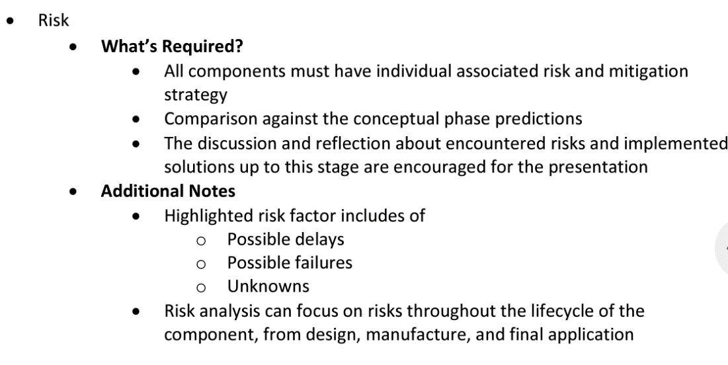

Innovation
The brakes project has experienced low to medium innovation. A number of the key components have been analysed, compared to different options and justified. A few key components will be manufactured impacting the factor of safety which will need to be tested to ensure legal standards and road-user safety is kept.
- Brake discs – medium innovation
  - Bolted disc was chosen off the shelf
  - Manufacture of the mounting bell – medium innovation
  - Reason: Allows for student involvement
- Handbrake – high innovation
  - Hand brake chosen overws2a electronic brake
  - Manufacturing in house
  - Reason: Allows for student involvement
- Hard and braided brake lines chosen – low innovation
  - Will be sourced off the shelf
  - Reason: manufacturing not possible by students
- Pull type master cylinder – low innovation
  - Either CP6461 or CP6465
  - Sourced off the shelf from AP Racing
  - Reason: technical limitations (high failure risk/safety issues)
- Front and rear callipers – low innovation
  - Chosen off the shelf from AP Racing
  - https://apracing.com/race-car/brake-calipers/pro-5000-r-range/4-piston-cp9440-2-3s4l-front-4712cm2-piston-area?switch=0
  - https://apracing.com/race-car/brake-calipers/pro-5000-r-range/4-piston-cp9441-2-3s4l-rear-3619cm2-piston-area?switch=0
  - Reason: manufacturing not possible by students
- Brake pads – low innovation
  - Sourced off the shelf from AP Racing
  - https://apracing.com/race-car/brake-pads/4-piston-caliper-pad-profiles/cp3215d50
  - https://apracing.com/race-car/brake-pads/4-piston-caliper-pad-profiles/cp3215d50
  - Reason: manufacturing not possible by students
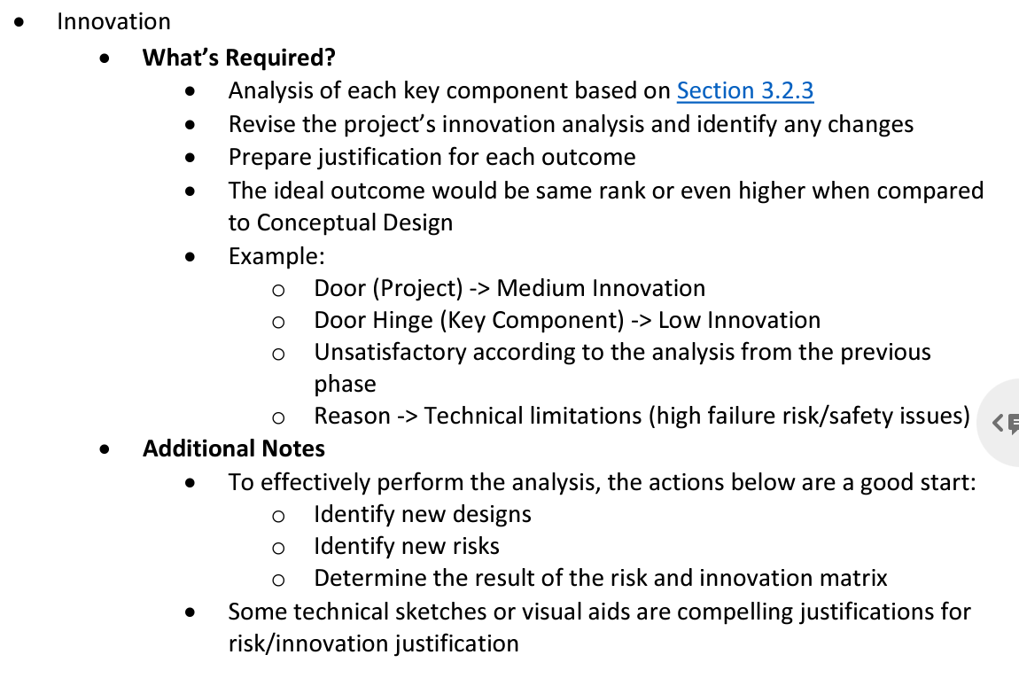

Manufacture and Procurement
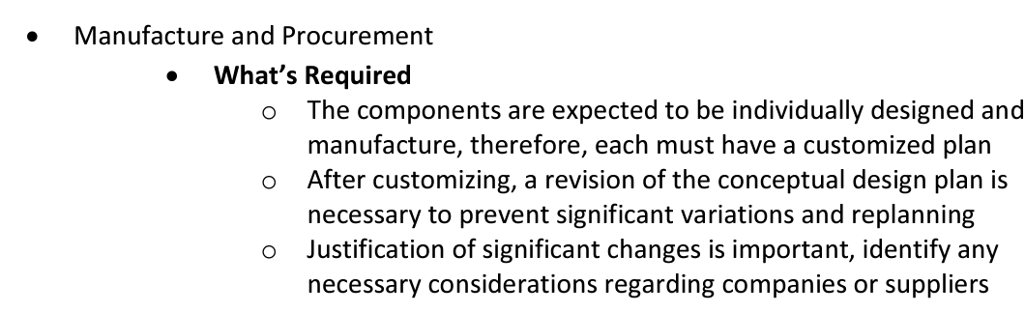
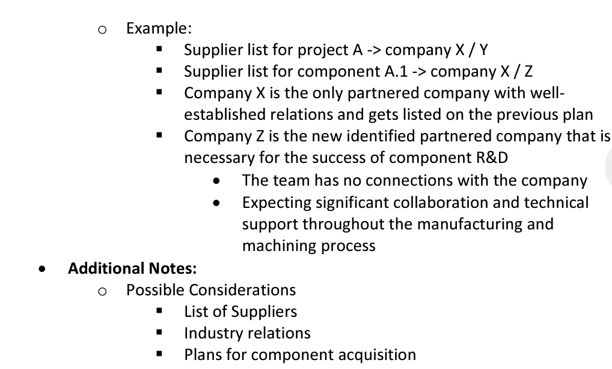

Design and Production Plan
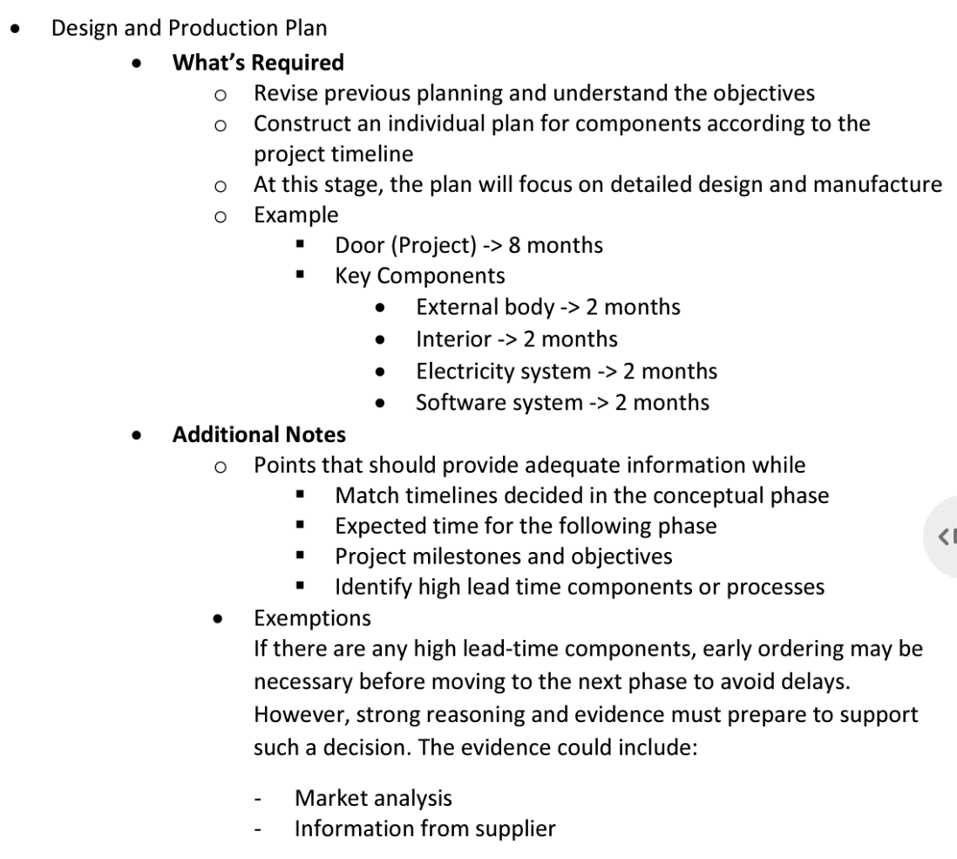

Cost Analysis

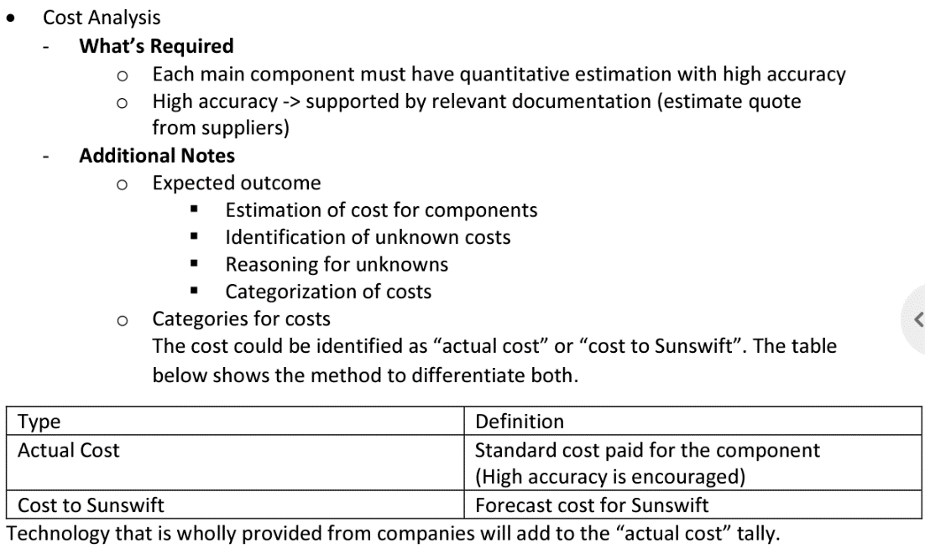

Educational Outcome
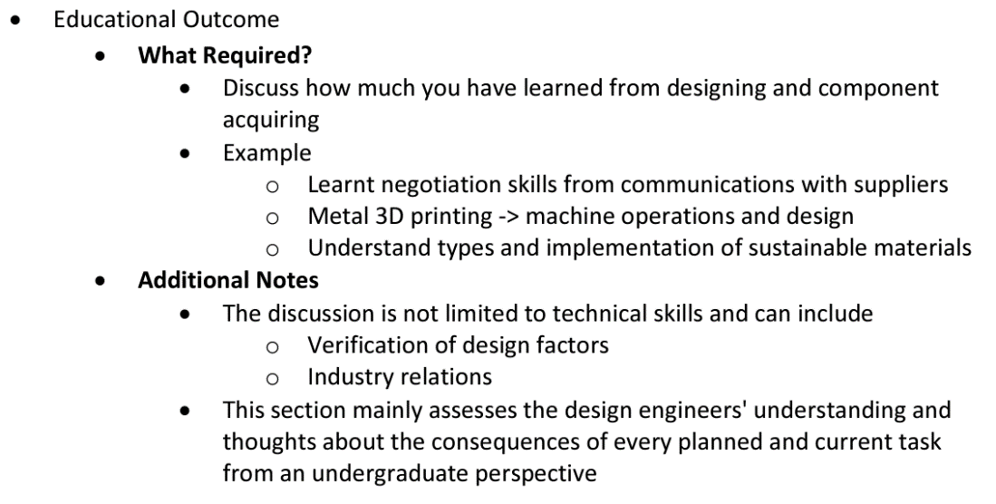

Upskilling Development
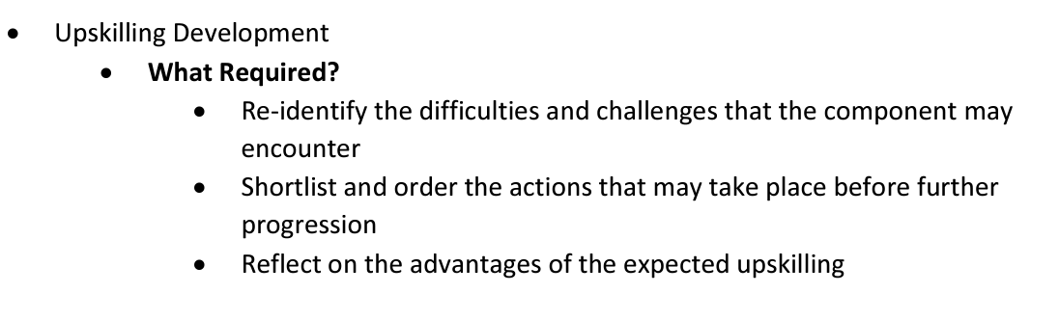

2.3 - Preliminary Requirements

Functional Requirements
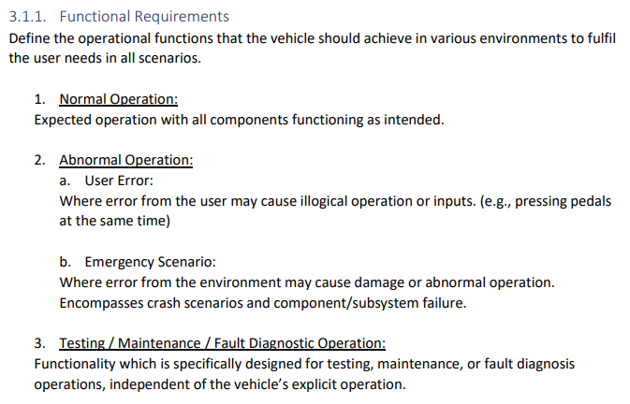
Emergency Scenarios

User Error

Testing/Maintenance/Fault diagnostic

Performance Requirements
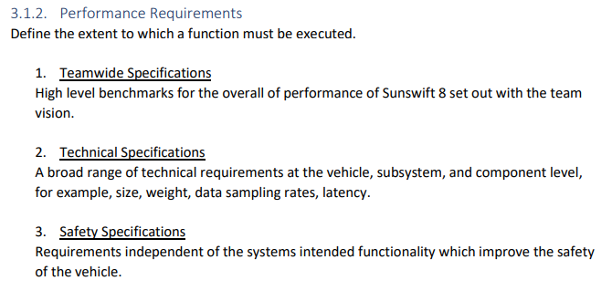

Teamwide specifications

Technical specifications

Safety specifications

Reliability Requirements
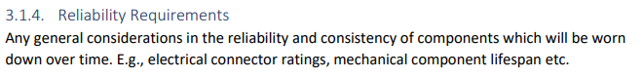

Interface Requirements
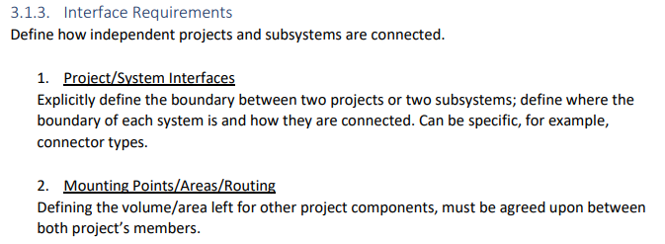

Project/System interfaces

Mounting points/Area/Routing

External Requirements
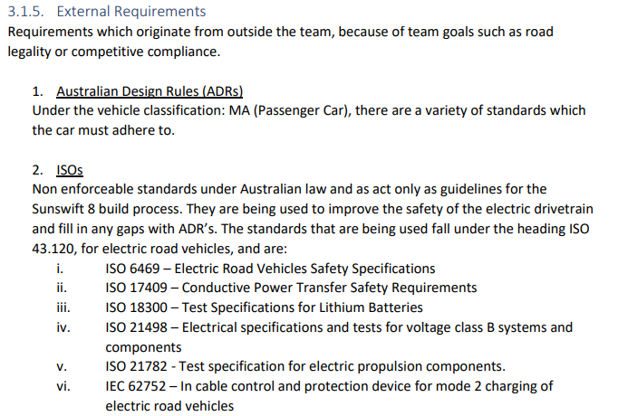
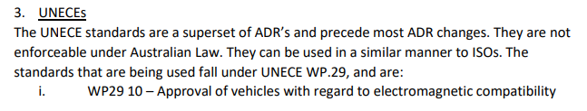
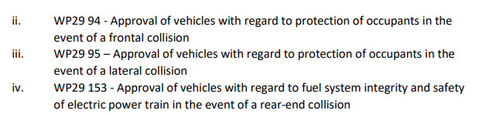

Design comparison

References

Quiroga, T. 2010, Effects of Upsized Wheels and Tires Tested, Car and Driver, <https://www.caranddriver.com/features/a15130598/upsized-wheels-tires/>

